# Media Analysis - ChatGPT outperforms copywriters in STEP Conference’s outdoor adverts

## Short Summary

The article discusses ChatGPT's superior performance in creating taglines for STEP Conference's outdoor adverts, prompting the company to explore broader AI integration while acknowledging potential job displacement concerns and valuing human creativity.

## Summary

1. The article discusses the use of ChatGPT in creating taglines for STEP Conference's outdoor adverts, which were deemed superior by both STEP and their agency Mink compared to internally generated or agency-created taglines.  
2. The company plans to continue using AI tools like ChatGPT across their team for various tasks such as content creation, summarization, and explanation.  
3. ChatGPT is perceived by STEP's team as an artificial intelligence assistant that enhances efficiency and speed in their work.  
4. The article references movies like 'Her' and 'Ex Machina' to contextualize the broader conversation about AI and its potential impacts on society.  
5. Experts argue that while AI can eliminate certain jobs, it also creates new ones; a report suggests 85% of future jobs do not yet exist.  
6. The rise of alternative AI tools like Meta's Open Pretrained Transformer, Microsoft's Bing, and Google's Bard may further increase the use of chatbots and potentially threaten more jobs.  
7. Despite this, STEP founder Ray Dargham believes that AI tools will complement human talent rather than replace it entirely; he foresees humans finding more valuable uses for their skills while acknowledging that some replacement is inevitable.

## Question 1:

How do the media (in our case = the sample we are analyzing) frame the public discussion about ChatGPT? Are there certain **metaphors** that keep cropping up?

Metaphors ChatGPT as a tool that complements human talent rather than replacing it entirely.

## Question 2:

Which role does the Arabic World play in the field of Artificial Intelligence in this article according to the author? Answer with 'Not mentioned' if not applicable.

Not mentioned

## Question 3:

How helpful is Artificial Intelligence for the Arabic world based on this article?

The article suggests Artificial Intelligence is helpful for the Arabic world as it can enhance productivity and creativity. It was used to create adverts, write session briefs, design social posts, and generate general copy. The founder of STEP Conference, Ray Dargham, plans to continue using AI tools like ChatGPT across his team.

## Question 4:

What is the final message of the article that the author wants to convey? Keep your answer short and precise!

The final message conveys a balanced view on AI's impact on jobs. While acknowledging that AI tools may replace some tasks like copywriting , the article suggests that AI can also complement and enhance human capabilities, ultimately allowing humans to focus on more valuable tasks.

## Sentiment

The sentiment is 1

## Entities

STEP Conference, Dargham clari ed, STEP, STEP Conference's, AI, Microsoft, Google, Meta's Open Pretrained Transformer, Arab News, Dargham, Art, Ray Dargham

## Topic Clusters

### Cluster: AI-generated content

ChatGPT, Artificial Intelligence, AI

## Word Clouds

### Wordcloud of content

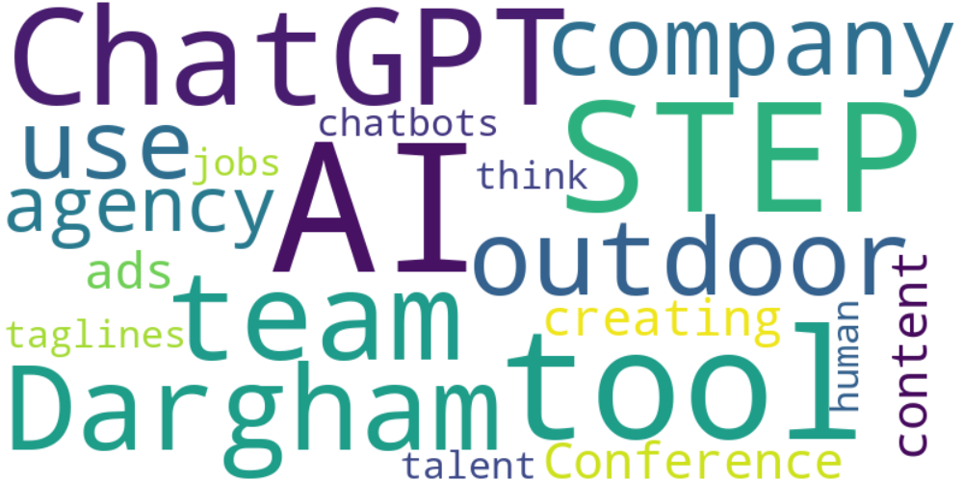

Top 10 words:

- AI: 10

- STEP: 7

- ChatGPT: 6

- like: 6

- team: 5

- Dargham: 5

- outdoor: 4

- company: 4

- use: 4

- agency: 4

### Wordcloud of summary



Top 10 words:

- AI: 5

- STEP: 4

- ChatGPT: 3

- tools: 3

- like: 3

- jobs: 3